Semester 3 individual project

S3-S-CB-03

Onea Bianca

Proof of database connection

November 5, 2021

Contents

1. SET UP IN INTELLIJ 2

2. SET UP IN MYSQL WORKBENCH 2

# 1. SET UP IN INTELLIJ

In the /main/resources/application.properties, I defined the required parameters for connecting the back-end application to the MySQL database.

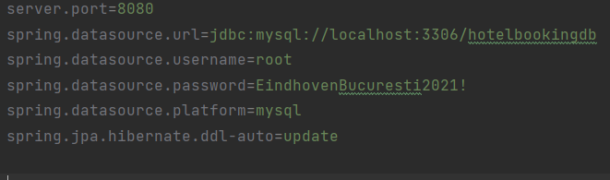

# 2. SET UP IN MYSQL WORKBENCH

For managing my MySQL database, I am using MySQL Workbench, where I can see the tables (added using ORM) and their records (added using Postman)

Below is the structure of the database

